Car Light Controller

INTERNAL LIGHT

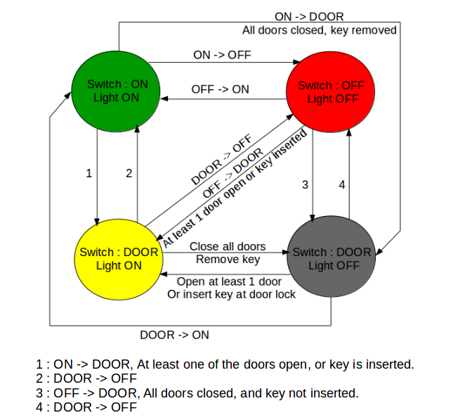

EXTERNAL LIGHTS

